PROBLEM STATEMENT:

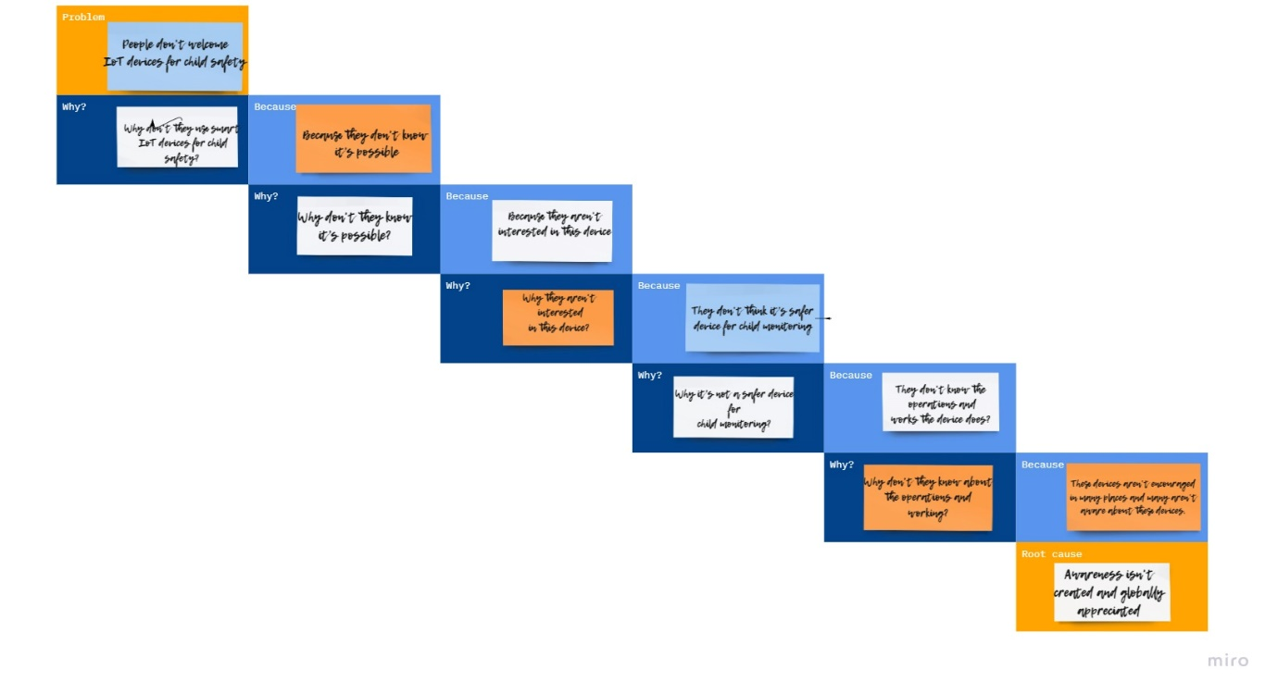

TEAM ID: PNT2022TMID37952

TEAM BATCH NO: B7-1A3

TEAM MENTOR: R. PADMAVATHY

TEAM LEADER: S. MADHUVANTHHI

TEAM MEMBERS: P. GLANY ROSE

V. POOJA

R. SANGETHAA

TEAM SIZE: 4